Microsoft Graph is a Microsoft developer platform that connects multiple services and devices. Initially released in 2015, the Microsoft Graph builds on Office 365 APIs and allows developers to integrate their services with Microsoft products, including Windows, Office 365, and Azure.

At its Build 2017 conference, Microsoft announced it would use the Microsoft Graph to bring new functionality and connectivity between Windows and other OS platforms, including Android and iOS.

In this Snippet we will show how to exploit the Microsoft Graph Azure Active Directory Capabilities by:

* Creating a User in Office 365 AD.
* Set User Location to USA.
* Assign Office 365 Licenses E3 and Power BI.

Microsoft Graph is consumed as a REST API.

Please review the official documentation in the following website:

<https://developer.microsoft.com/en-us/graph>

Our project comes from the need to automate the creation of Office 365 users and license them when a new hire comes in.

Our Robot connects to Microsoft Graph API using an application key.

We first get a token to work with.

We then create user.

We assign a user location (USA)

We assign the required licenses for this use case is E3 and Power BI.

For Security reasons we cannot provide the Keys to our instance however if you want to test it on your own all you need is to update the application key and application secret.

You can get them by creating a new application in Azure AD and giving it the right permissions for the transactions you need to perform.

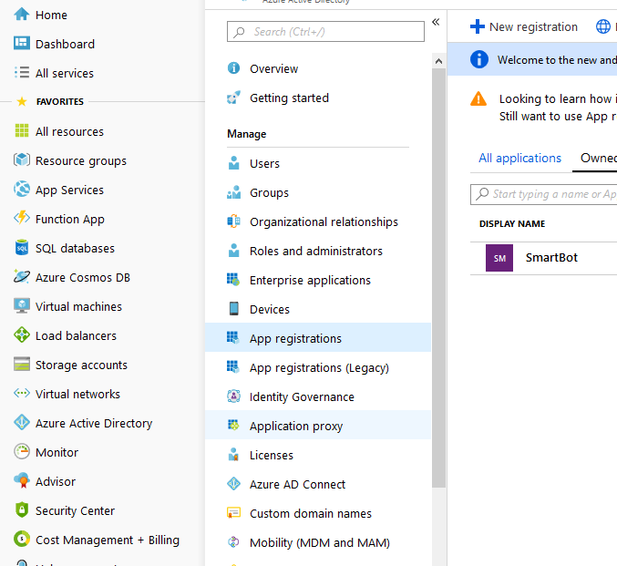

You might need to update the License codes in the Json request but since I don’t have access to any other instance I can’t tell for sure.

Happy Coding !!